Multiple-choice section

|  |  |  |  |  |  |  |
| --- | --- | --- | --- | --- | --- | --- |
| Question | 1 | 2 | 3 | 4 | 5 | 6 |
| Answer | A | D | B | D | C | A |

Question 1 [8.3]

A

P(x) = x3 – x2 – 2

P(2) = (2)3 – (2)2 – 2

= 8 – 4 – 2

= 2

Question 2 [8.2]

D

To transform y = -x2 to y = 3x2, dilate by a factor of 3 in the y-direction.

To transform y = 3x2 to y = 3x2 + 6, translate it 6 units up.

Question 3 [8.3]

B

P(x) = 2x5 + x2 + 3

Degree = 5; Leading coefficient = 2; Constant = 3

Question 4 [8.3]

D

P(x) = x3 – x2 + 3x – 2

P(1) = 13 – 12 + 3 × 1 – 2

= 1 – 1 + 3 – 2

= 1

Question 5 [8.5]

C

y = 5x3 – 2x − 6

For x = 0: y = -6

Question 6 [8.2]

A

y = x3

Dilating by a factor of 4: y = 4x3

Translating the graph 3 units down: y = 4x3 – 3

Multiple-choice total marks: 6

Short answer section

Question 7 3 marks [8.1, 8.3]

(a) A polynomial with an equation y = x3 + 2x2 – 7 is a cubic equation.

(b) The equation y = 3x2 – 4x + 1 is a non-monic quadratic equation.

(c) In a polynomial, the term with the highest power is called the leading term.

Question 8 1 mark [8.2]

When a polynomial is translated, the graph is moved right or left and/or up or down without the shape being changed.

Question 9 4 marks [8.2]

(a), (c)

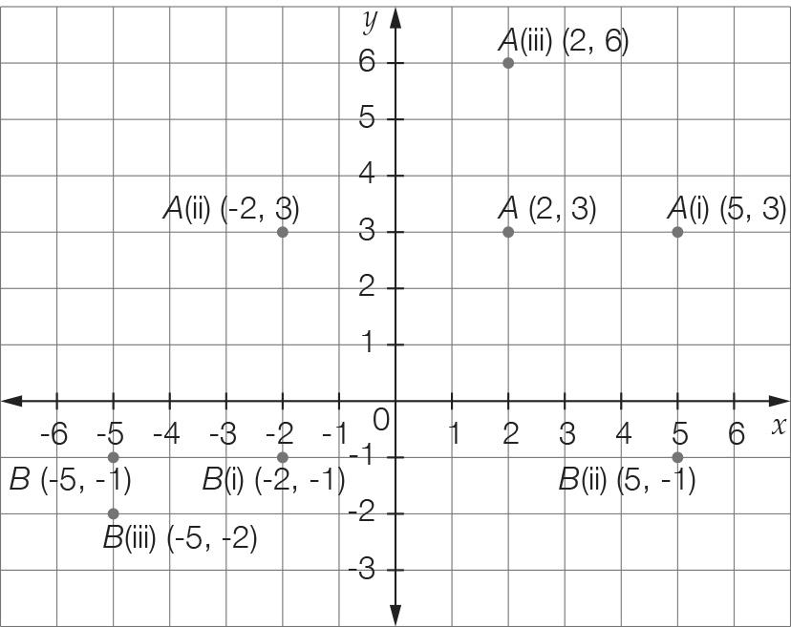

(b) A (i) (5, 3) (ii) (-2, 3) (iii) (2, 6)

B (i) (-2, -1) (ii) (5, -1) (iii) (-5, -2)

Question 10 8 marks [8.2, 8.5]

(a) (i) (0, -4) (ii) (-2, 0) and (2, 0)

(b), (c)

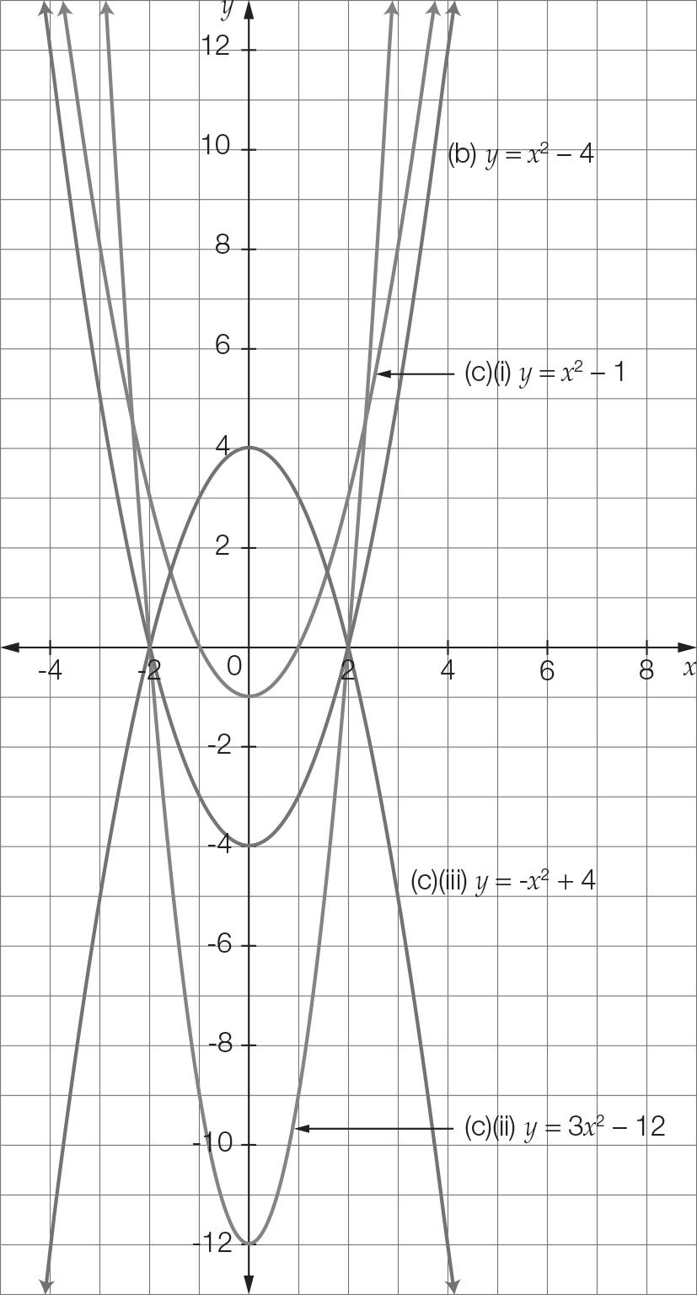

(c) (i) y = x2 – 1 (ii) y = 3x2 – 12 (ii) y = -x2 + 4

Question 11 4 marks [8.1]

(a)

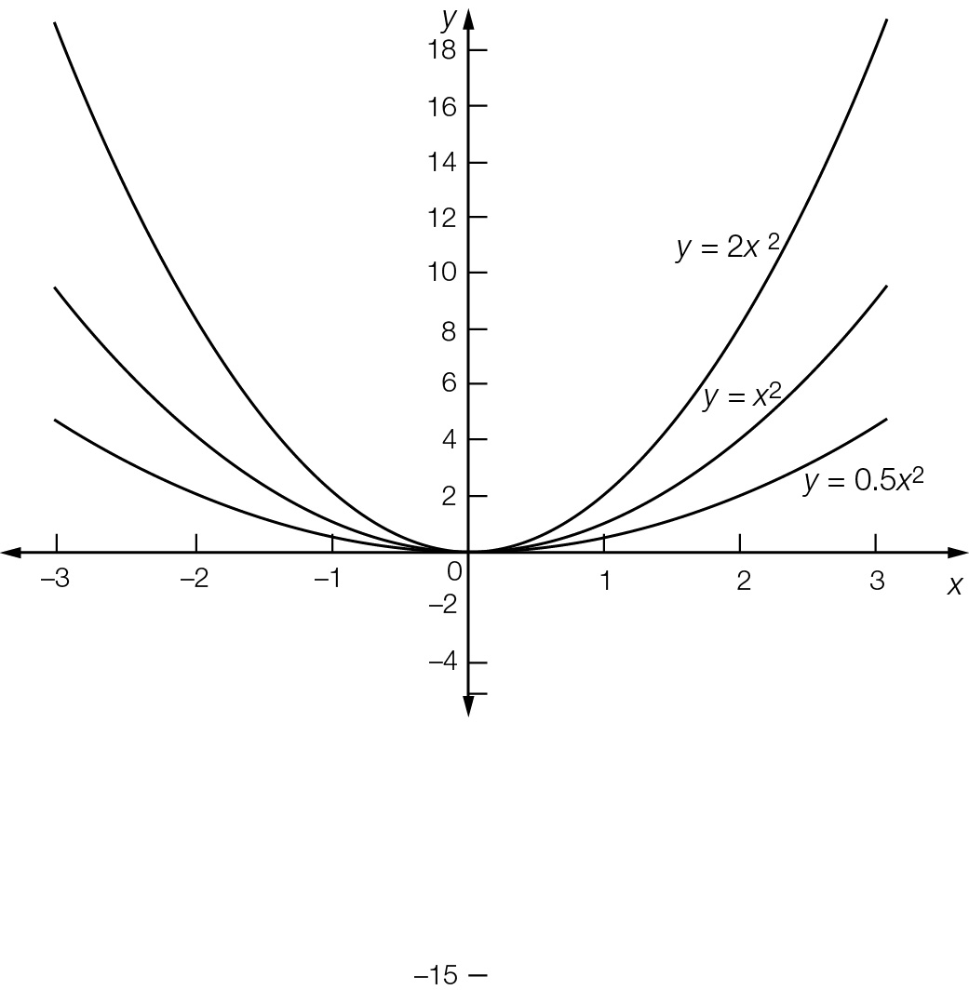

(b) The shape becomes narrower as the coefficient of x2 increases.

Question 12 3 marks [8.2]

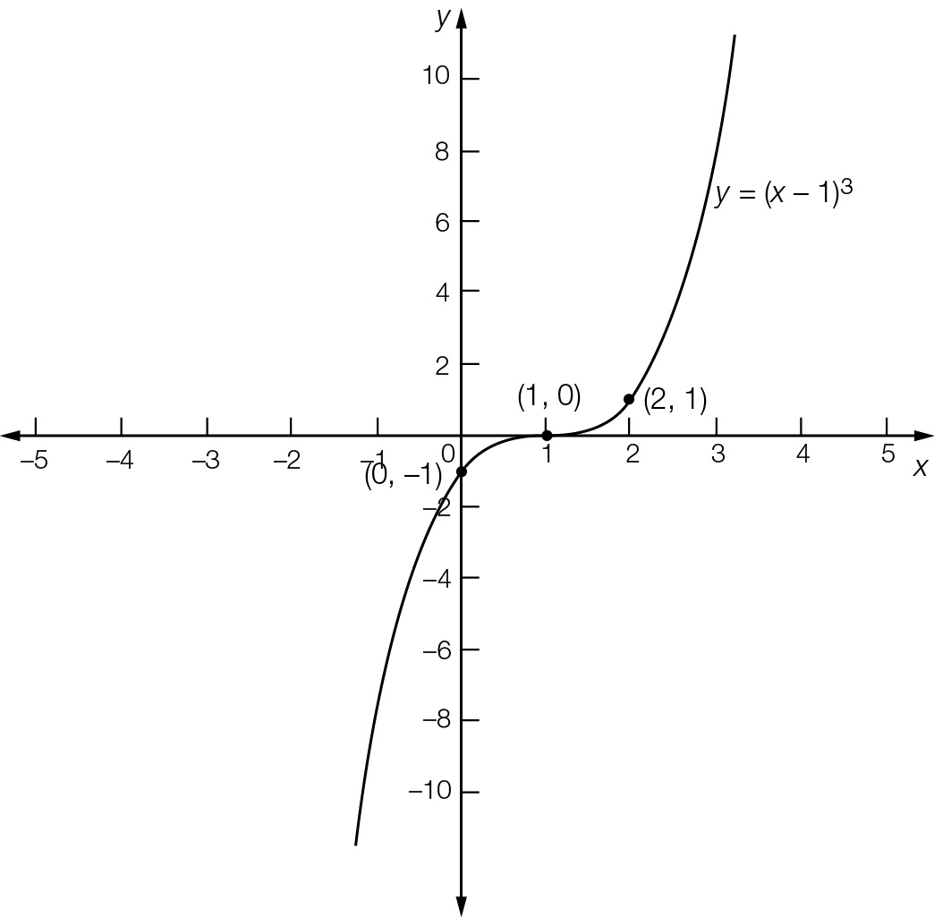

Point of inflection = (1, 0)  
y-intercept = (0, -1)  
Required point = (2, 1)

Question 13 4 marks [8.2]

(a) y = x2  
Translate 4 to the left: y = (x + 4)2   
Translate 4 to the left and 3 down: y = (x + 4)2 – 3

(b) y = x2  
Reflect in the x-axis: y = -x2  
Reflect in the x-axis, dilate by 2 in the x-direction: y = -2x2  
Reflect in the x-axis, dilate by 2 in the y-direction, translate 1 to the right: y = -2(x – 1)2

Question 14 5 marks [8.5]

x = 0, c = -16

x = -2, 4a – 2b – 16 = 0

x = 4, 16a + 4b – 16 = 0

24a = 48 a = 2

8 − 2b − 16 = 0

b = -4

a = 2, b = -4, c = 16

Question 15 2 marks [8.3]

Answers will vary, but the polynomial must have four terms, the highest power of x must be 5 and it must have a constant term. e.g. 2x5 + 3x2 + 5x – 2

Question 16 4 marks [8.3]

2a(x) × b(x) − c(x)

= 2(2x – 3)(5 – 2x2) − (3x3 + 5x – 4)

= 20x − 8x3 – 30 + 12x2 − 3x3 − 5x + 4

= -11x3 + 12x2 + 15x – 26

Question 17 4 marks [8.2]

(a) Translated 3 units right: y = x – 3  
Now translated 1 unit down: y = x – 4

(b) Translated 1 unit down: y = x – 1  
Now translated 3 units right: y = x – 4

This is the same answer as in part (a).

Question 18 2 marks [8.3]

Answers will vary. P(1) = 0. For example: P(x) = x3 + 3x2 – x – 3

Question 19 2 marks [8.3]

x2 – kx + 6 Substitute x = 2:

P(2) = (2)2 – 2k + 6 = 0

2k = 10

k = 5

Question 20 5 marks [8.3, 8.4]

(a)

*x*2**–** 3*x* **–** 4

x – 1 ) x3 − 4x2 − x + 4

-(*x*3 – *x*2)

-3x2 − x

-(-3*x*2+ 3*x*)

-4x + 4

-(-4*x* + 4)

0

So x – 1 is a factor.

(b) P(x) = (x – 1)(x2 – 3x − 4)

= (x – 1)(x + 1)(x − 4)

Short answer total marks: 51

Extended answer section

Question 21 5 marks [8.2]

(a) y = 12 – (x – 4)2

= 16 – (x – 4)2

(b) Let y = 0

16 – (x – 4)2 = 0

(x – 4)2 = 16

x – 4 = ±4

x = 0, 8

x = 0 m and 8 m

(c) Maximum height at vertex (4, 16) is 16 m.

Question 22 6 marks [8.5]

(a) y = 0.01(x3 – 28x2 + 160x)

= 0.01x(x2 – 28x + 160)

= 0.01x(x – 8)(x – 20)

Let y = 0 and solve for x.  
x = 0, 8, 20

The coordinates of the x-intercepts are (0, 0), (8, 0) and (20, 0).

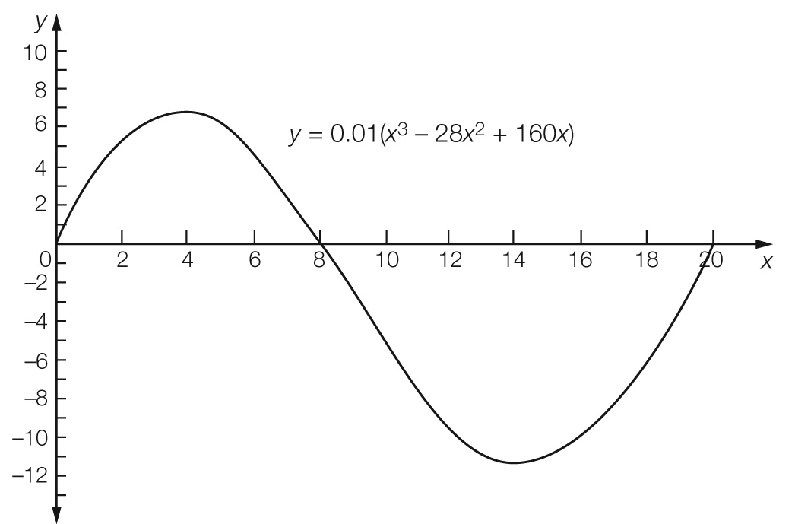

(b)Distances are 0 m, 8 m, 20 m.

(c) Distance from one side to the other  
= 20 – 0 = 20 m

Extended answer total marks: 11

TOTAL test marks: 68